# COMPUTER NETWORKS LAB EXAM 2

## OBJECTIVE:

## Set up and configure a network topology using RIP and OSPF routing protocols in Cisco Packet

## Tracer. Customize the network by assigning each computer a name and an IP address using the

## last three digits of your roll number.

## **STEPS TAKEN**:

**STEP 1:**

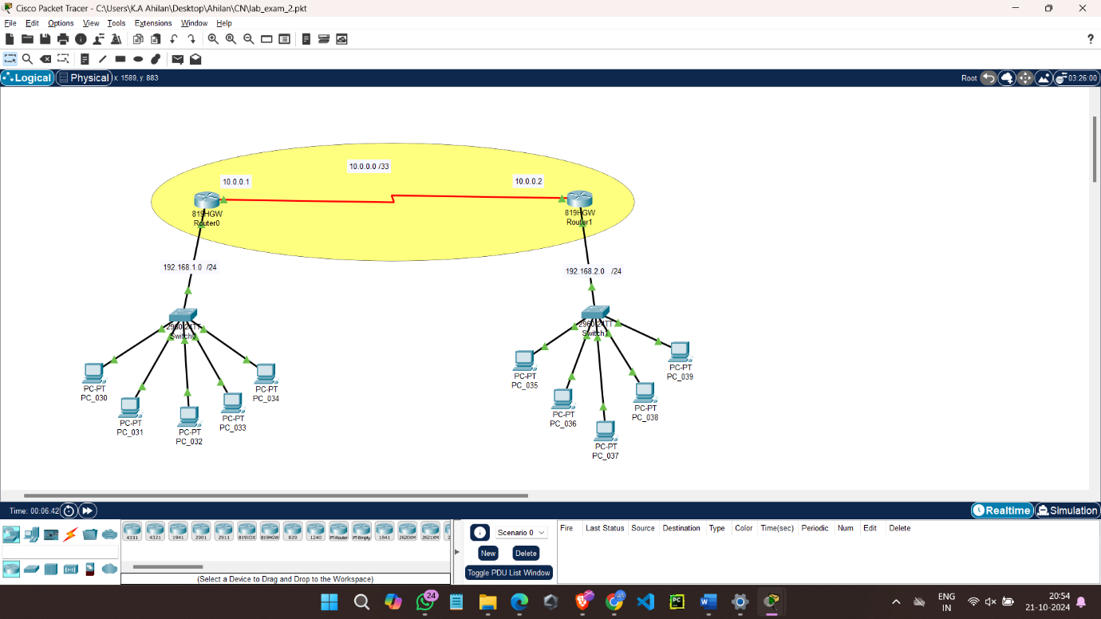

* Link the two routers with a Serial DCE-DTE cable.
* Connect the GigabitEthernet ports of R1 and R2 Routers to the Switch (SW0/SW1) ports with a straight-through cable.
* Connect PC_030 t0 PC_034 to SW1, PC_035 to PC_039 to SW2 with a straight cable.

**STEP 2:**

After typing the below commands on the Router, the connection is successful indicated by the green triangles on the cables below.

Click on the R1 Router you made in the setup, and open the settings. After that, go to the CLI tab. Use the commands below to give IP addresses to R1’s GigabitEthernet and Serial ports.

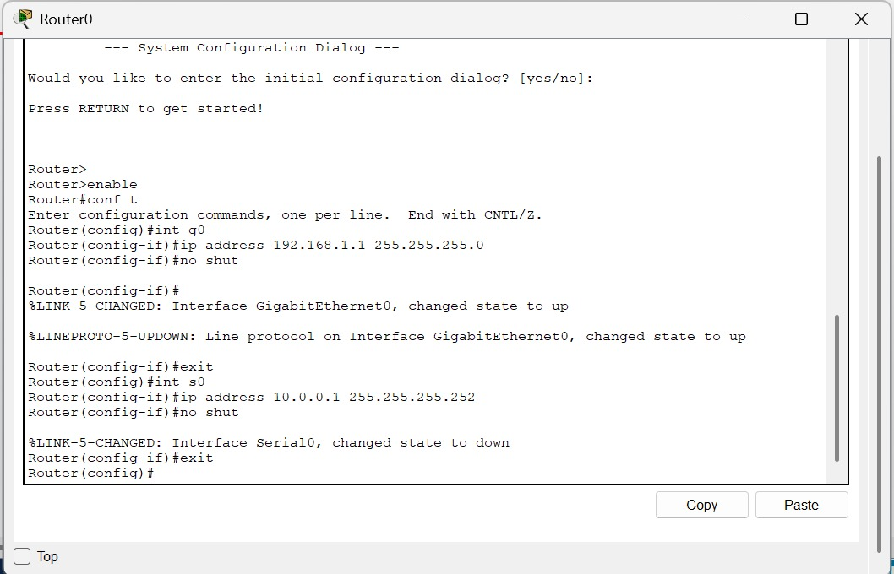

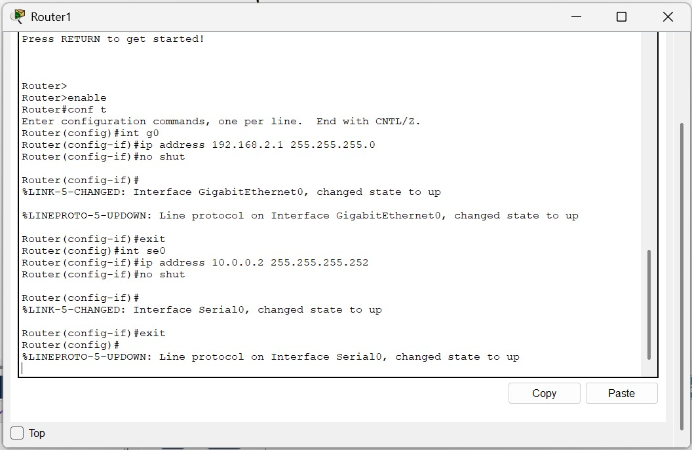

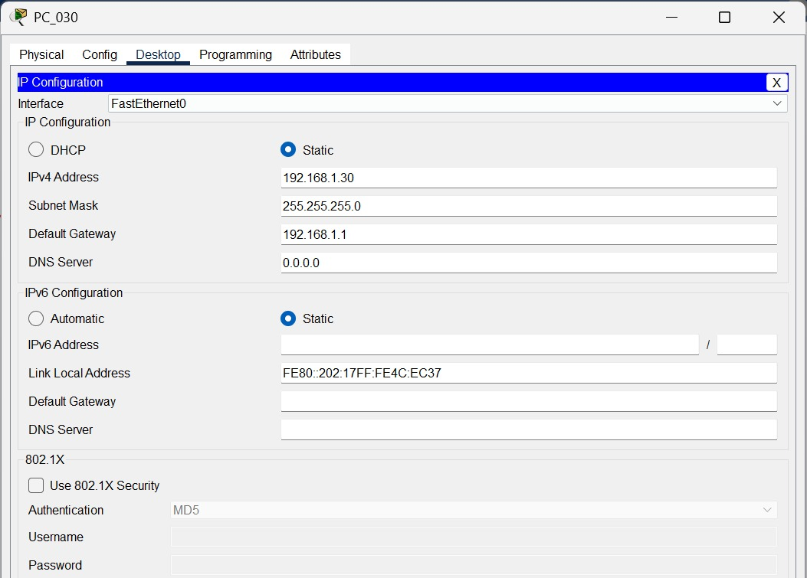

**STEP 3:**

Setting up RIP Protocol on Router 0

Enabling RIP Configuration

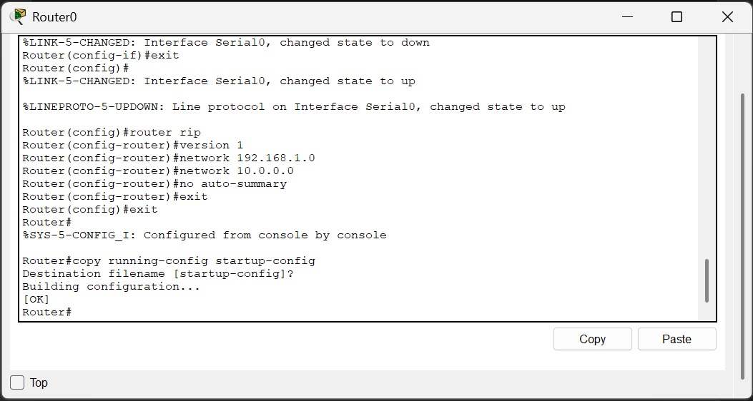

OSPF on Router 1

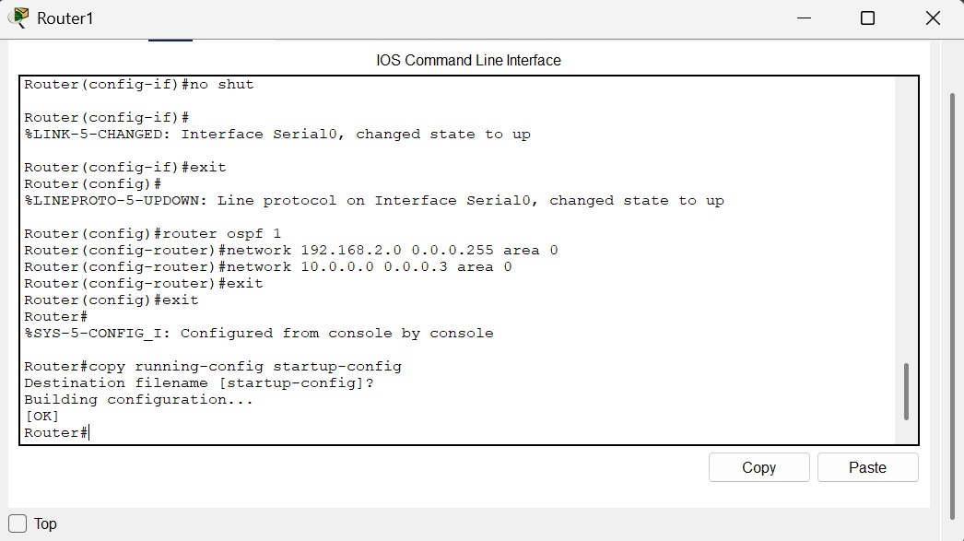

**STEP 4:**

Pinging to check the connectivity

